UCS 1602 - Compiler Design

**Assignment-3**

Elimination of Immediate Left Recursion using C

**Swetha Saseendran**

**CSE-C**

**185001183**

**Aim:**

To write a program in C to find whether the given grammar is Left Recursive or not. If it is found to be left recursive, convert the grammar in such a way that the left recursion is removed.

**Elimination of Left Recursion**:

If we have the left-recursive pair of productions-

**A**→**Aα | β** (Left Recursive Grammar)

Then, we can eliminate left recursion by replacing the pair of productions with:

**A**→ **βA’**

**A’**→ **αA’ | ∈**

(Right Recursive Grammar)

**Code:**

#include<stdio.h>

#include<string.h>

/* FUNCTIONS */

int getProds(char a[50][100]);

void postProds(char nt[],char prod[100][100],int n);

int prodStatus(char prod[],char prodRHS[100][100],char nt[],int k);

char getNT(char a[]);

int getProductionRHS(char a[],char prodRHS[100][100]);

int isLR(char nt,char prodRHS[100][100],int n);

int getBetaList(char nt,char prodRHS[100][100],int n,char beta[100][100]);

int getAlphaList(char nt,char prodRHS[100][100],int n,char alpha[100][100]);

void modifyBeta(char nt,char beta[100][100],char beta_mod[100][100],int n);

void modifyAlpha(char nt,char beta[100][100],char alpha_mod[100][100],int n);

//-----------------------------------------------------------------------------------------

void main()

{

    char a[50][100];

    int n,status = 0;

    n = getProds(a);

    for(int i = 0;i<n;i++)

    {

        char nt[5];

        char prodRHS[100][100];

        int k;

        nt[0] = getNT(a[i]);

        nt[1] = '\0';

        k = getProductionRHS(a[i],prodRHS);

        if(status == 0)

            status = prodStatus(a[i],prodRHS,nt,k);

        else

            prodStatus(a[i],prodRHS,nt,k);

    }

    if(f == 1)

        printf("\n\t\t GRAMMAR IS LR\n");

    else

        printf("\n\t\t GRAMMAR IS GOOD TO GO\n");

    for(int i = 0; i < n; i++) //for each prod

    {

        char nt[3];

        char prodRHS[100][100],alpha[100][100],beta[100][100],alpha_mod[100][100],beta_mod[100][100];

        int k,alpha_c,beta_c;

        int flag = 0;

        nt[0] = getNT(a[i]);

        nt[1] = '\0';

        k = getProductionRHS(a[i],prodRHS);

        if(isLR(nt[0],prodRHS,k))

        {

            alpha_c = getAlphaList(nt[0],prodRHS,k,alpha);

            beta_c = getBetaList(nt[0],prodRHS,k,beta);

            modifyBeta(nt[0],beta,beta_mod,beta_c);

            modifyAlpha(nt[0],alpha,alpha_mod,alpha_c);

            char newnt[5];

            n_nt[0] = nt[0];

            n_nt[1] = '\'';

            n_nt[2] = '\0';

            postProds(nt,beta_mod,beta_c);

            postProds(n_nt,alpha_mod,alpha_c+1);

        }

        else

        {

            postProds(nt,prodRHS,k);

        }

    }

}

//-----------------------------------------------------------------------------------------

/* DEFINED FUNCTIONS */

int getProds(char a[50][100])

{

    int n;

    printf("Enter the number of productions in the grammar: ");

    scanf("%d",&n);

    for(int i = 0; i<n;i++)

    {

        printf("Enter Production-%d:  ",i+1);

        scanf("%s",a[i]);

    }

    return n;

}

void postProds(char nt[],char prod[100][100],int n)

{

   printf("%s->%s",nt,prod[0]);

   for(int i = 1; i < n; i++)

   {

     printf("|%s",prod[i]);

   }

   printf("\n");

}

int prodStatus(char prod[],char prodRHS[100][100],char nt[],int k)

{

    int flag  = 0;

    if(isLR(nt[0],prodRHS,k))

    {

        printf("%s is LR\n",prod);

        flag = 1;

    }

    else

        printf("%s is not LR\n",prod);

    return flag;

}

char getNT(char a[])

{

  return a[0];

}

int getProductionRHS(char a[],char prodRHS[100][100])

{

  int i = 0;

  while(a[i]!='>') i++; //RHS

  int k = 0,t = 0,j = 0;

  char temp[100];

  while(a[i]!='\0'){

    i++;

    if(a[i]=='|'||a[i]=='\0')

    {

      temp[j] = '\0';

      strcpy(prodRHS[k++],temp);

      j =0;

      temp[j] = '\0';

    }

    else

    {

      temp[j++] = a[i];

    }

  }

  return k;

}

int isLR(char nt,char prodRHS[100][100],int n)

{

  for(int i = 0;i<n;i++)

  {

    if(prodRHS[i][0]==nt)

        return 1;

  }

  return 0;

}

int getBetaList(char nt,char prodRHS[100][100],int n,char beta[100][100])

{

   int k = 0;

   for(int i = 0;i<n;i++)

   {

     if(prodRHS[i][0]!=nt)

     {

       strcpy(beta[k],prodRHS[i]);

       //printf("BETA: %s\n",beta[k]);

       k++;

     }

   }

   return k;

}

int getAlphaList(char nt,char prodRHS[100][100],int n,char alpha[100][100])

{

  int k = 0;

  char temp[100];

   for(int i = 0;i<n;i++)

   {

     if(prodRHS[i][0]==nt)

     {

       int pos = 0,j = 1;

       temp[pos]='\0';

       while( j < strlen(prodRHS[i]) )

       {

           temp[pos] = prodRHS[i][j];

           pos++;

           j++;

       }

       temp[pos]='\0';

       strcpy(alpha[k],temp);

       //printf("ALPHA: %s\n",alpha[k]);

       k++;

     }

   }

   return k;

}

void modifyBeta(char nt,char beta[100][100],char beta_mod[100][100],int n)

{

  if(n!=0)

  {

    for(int i = 0;i < n ; i++)

    {

      char temp[100]="",temp1[5];

      strcat(temp,beta[i]);

      temp1[0]=nt;

      temp1[1]='\'';

      temp1[2]='\0';

      strcat(temp,temp1);

      strcpy(beta_mod[i],temp);

    }

  }

  else

  {

    char temp1[5];

    temp1[0]=nt;

    temp1[1]='\'';

    temp1[2]='\0';

    strcpy(beta_mod[0],temp1);

  }

}

void modifyAlpha(char nt,char alpha[100][100],char alpha_mod[100][100],int n)

{

  int i;

  for( i = 0;i < n ; i++)

  {

    char temp[100]="";

    strcat(temp,alpha[i]);

    int l = strlen(temp);

    temp[l]=nt;

    temp[l+1]='\'';

    temp[l+2] = '\0';

    strcpy(alpha_mod[i],temp);

  }

  strcpy(alpha_mod[i],"ep");

}

**OUTPUT:**

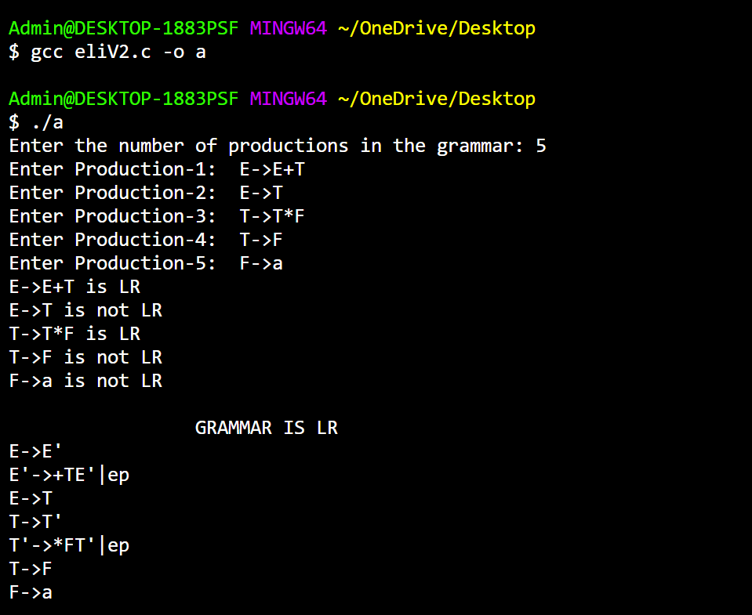

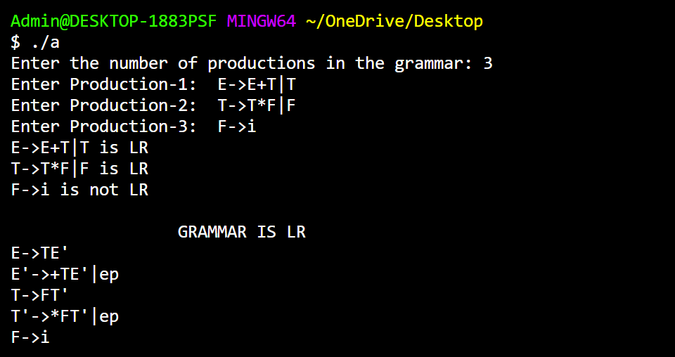

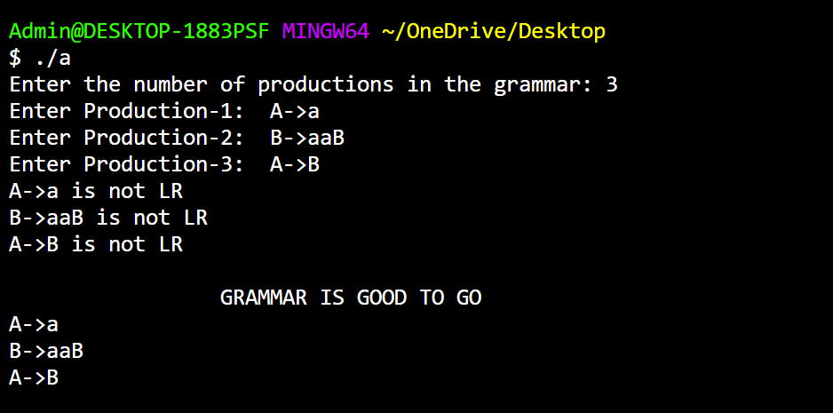

**LEARNING OUTCOME:**

* Learnt that a production of grammar is said to have left recursion if the leftmost variable of its RHS is same as variable of its LHS.
* Understood the need for this type of conversion, as top-down parsers cannot handle left recursive grammars.
* Strengthened my knowledge and skills in string operations and to parse each production in input to check if its left recursive or not.
* Learnt to modularise long code into functions and follow the best practices.
* Was able to perform a check of whether or not a grammar is left recursive using C.

**RESULT:**

Successfully implemented the code to check whether the given grammar is Left Recursive or not and convert the grammar in such a way that the left recursion is removed.